Subject: FW: SUSPECT: FW: Amazing picture!

As we grow up, we learn that even the one person that wasn't supposed to ever let you down probably will. You will have your heart broken probably more than once and it's harder every time. You'll break hearts too, so remember how it felt when yours was broken. You'll fight with your best friend. You'll blame a new love for things an old one did. You'll cry because time is passing too fast, and you'll eventually lose someone you love. So take too many pictures, laugh too much, and love like you've never been hurt because every sixty seconds you spend upset is a minute of happiness you'll never get back.
Don't be afraid that your life will end,
be afraid that it will never begin.
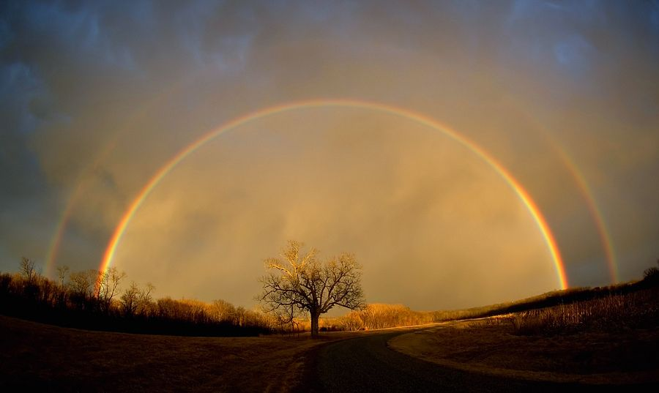
Send this to all of your friends in the next 5 minutes
and a miracle will happen tonight

